Module 3: Python for AI and ML

- What is Python?
Python is a popular, high-level programming language known for its simplicity and readability. It was created by Guido van Rossum and first released in 1991. Python is widely used for web development, data analysis, automation, artificial intelligence, machine learning, game development ( 2D games or simple 3D games) and more.


- Python Install
Go to google and type download python for windows
https://www.python.org/downloads/
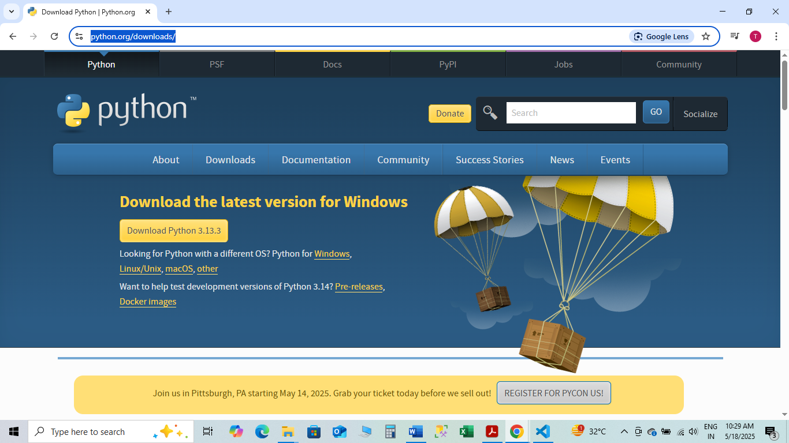
Click on Download python
Double click on set file downloaded

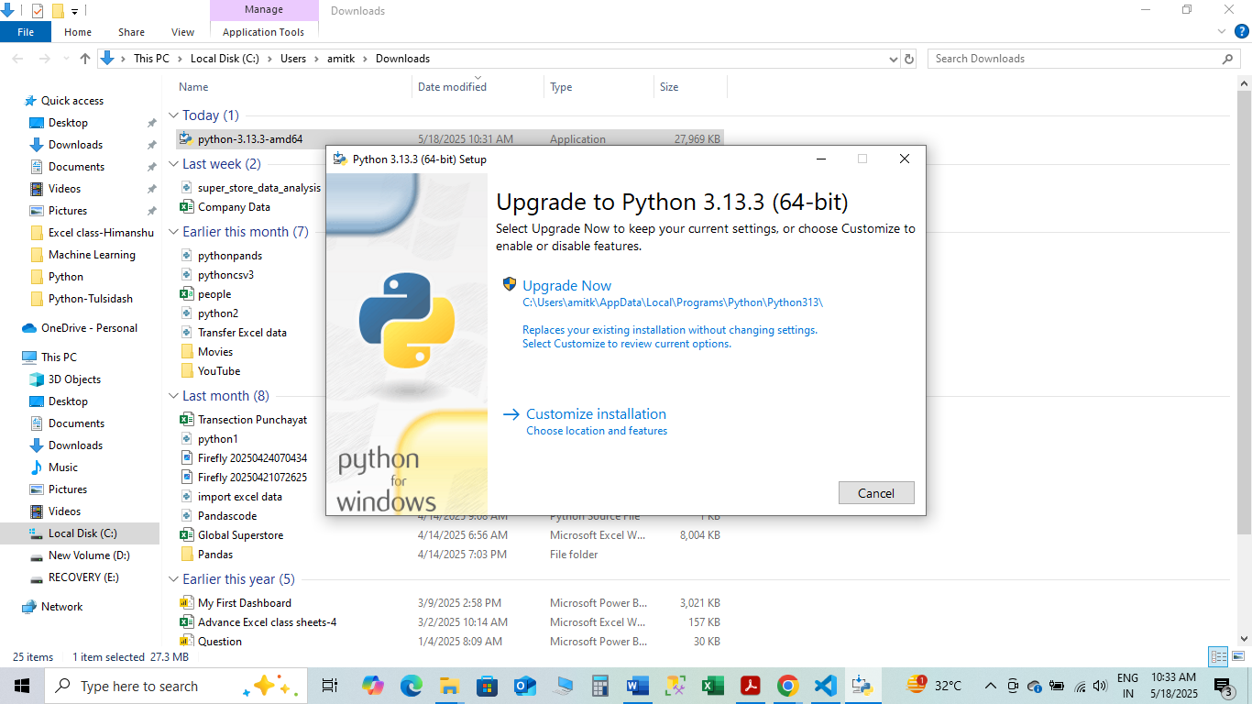
Click on Customize and installation
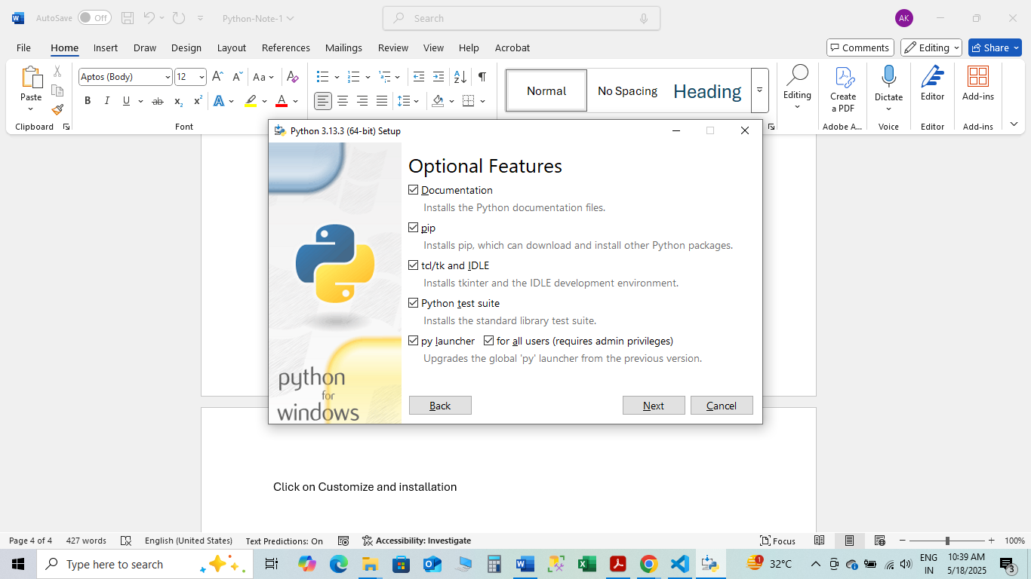
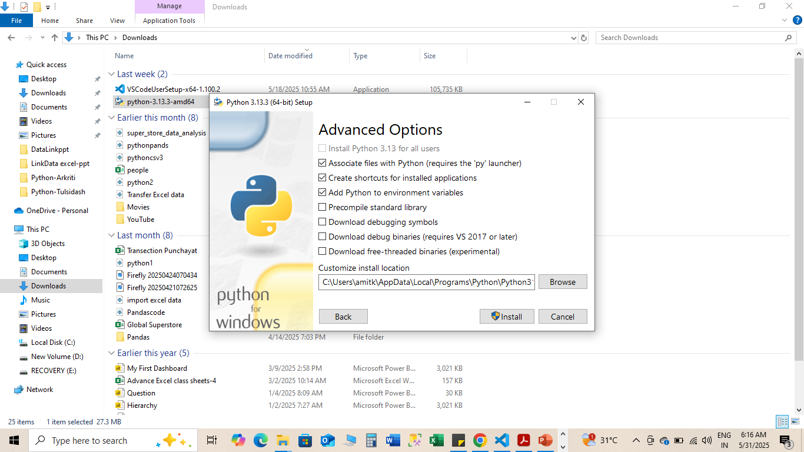
Check mark this
Click on Next
It will start installation
after installation go to cmd and type python –-version, it will show the python version

- Download Visual Studio Code
Type Download vs code window in google
https://code.visualstudio.com/download
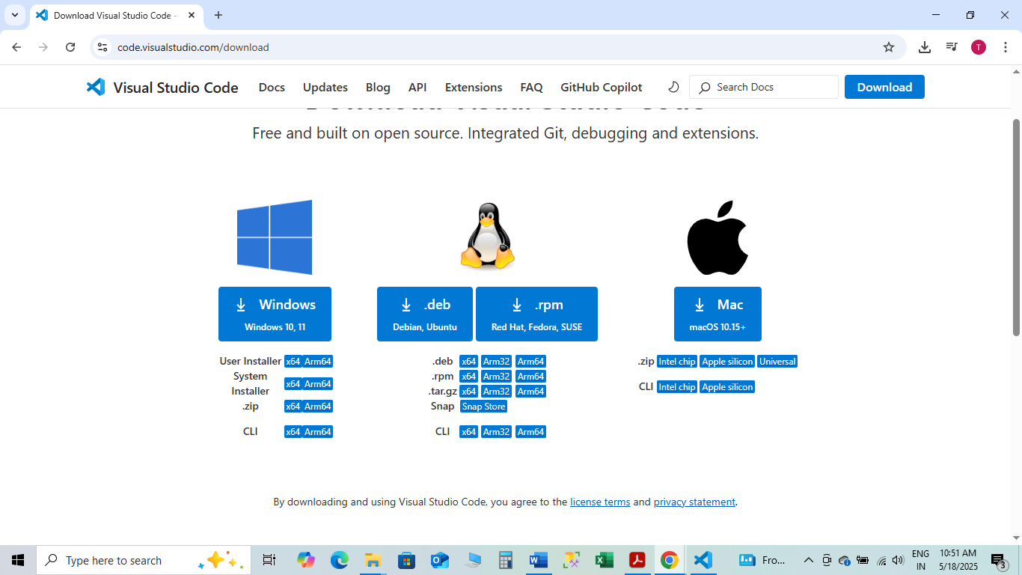
Click on download window, it start downloading Visual Studio Code set file
Click on I accept the agreement and click on Next
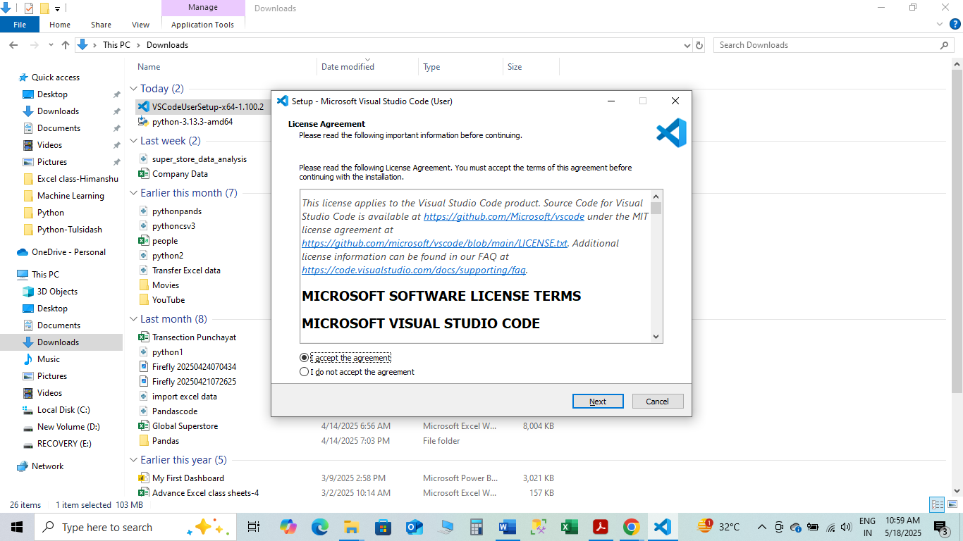

Select all check box and click on Next

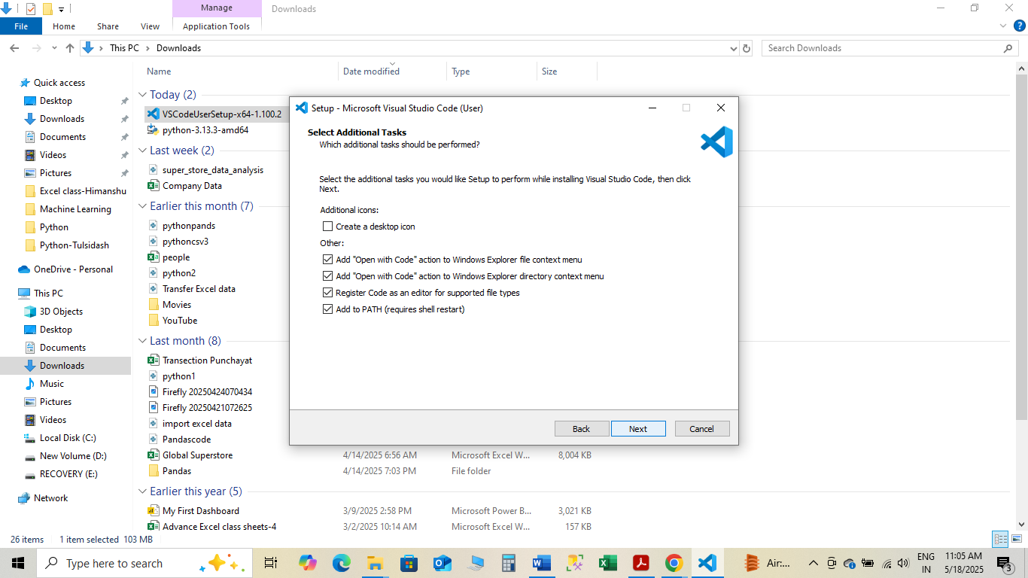
Uncheck this
Check mark this
It will install vs code

- Essential Python Libraries: NumPy, Pandas, Matplotlib, Scikit-learn, Scipy

- How to install Library in visual studio code for python

Go to Terminal----than go to new Terminal
PS C:\Users\amitk> python –-version (check the version of python)
Press Enter Button

Go to Terminal----than go to new Terminal
PS C:\Users\amitk> PiP list
Press Enter Button

same step for numpy
PS C:\Users\amitk> pip install numpy (press Enter)

same step for pandas
PS C:\Users\amitk> pip install pandas

same step for openpyxl
PS C:\Users\amitk> pip install openpyxl

same step for matplotlib
PS C:\Users\amitk> pip install matplotlib

same step for seaborn
PS C:\Users\amitk> pip install seaborn

same step for tkinter
(tkinter is already intall in python vs code, if not install than do this)
PS C:\Users\amitk> pip install tkinter

same step for customtkinter
PS C:\Users\amitk> pip install customtkinter

same step for pygame library
PS C:\Users\amitk> pip install pygame

same step for scipy
PS C:\Users\amitk> pip install scipy

same step for scikit-learn
PS C:\Users\amitk> pip install scikit-learn

- Why Python for AI/ML?
Python is the most widely used language for AI, ML, and Deep Learning because:
- Easy to learn and write (beginner-friendly).
- Huge ecosystem of libraries for data science & AI.
- Community support & open-source resources.
- Works well with big data, cloud, and visualization tools.

- Core Python Skills (Before ML/AI)
You should be comfortable with:
- Python Basics
  - Variables, loops, conditions, functions.
- Data Structures
  - Lists, Tuples, Dictionaries, Sets.
- OOP (Object-Oriented Programming)
  - Classes, inheritance, methods.
- Modules & File Handling
  - Importing libraries, working with files.
- Exception Handling
  - Try, except blocks for error management.

- Essential Python Libraries for AI/ML
Here are the main tools you’ll use:
- Numerical & Data Handling
  - NumPy → For arrays, linear algebra, matrix operations.
  - Pandas → For datasets, tables, cleaning & preprocessing.
- Visualization
  - Matplotlib & Seaborn → Graphs, heatmaps, data visualization.
  - Plotly → Interactive charts.
- Machine Learning
  - Scikit-learn → Classification, regression, clustering, model evaluation.
- Deep Learning
  - TensorFlow or PyTorch → Build neural networks.
  - Keras → High-level wrapper for TensorFlow (easy prototyping).
- Scientific Computing
  - SciPy → Statistics, optimization, scientific math.
- Natural Language Processing (NLP)
  - NLTK, spaCy, transformers.
- Others (Advanced Use)
  - OpenCV → Computer vision (image & video).
  - XGBoost, LightGBM → Boosting algorithms for structured data.

- Data Preprocessing and Feature Engineering

Data Preprocessing & Feature Engineering are the most critical steps in AI/ML. Models perform well only if the data is properly cleaned and features are engineered smartly.

  - Data Preprocessing:-
This step ensures the raw dataset is clean, consistent, and ready for training.

Common Steps:
- Import Data
  - Using pandas.read_csv() / read_excel() / read_sql()
- Handling Missing Data
  - Drop missing values (dropna)
  - Imputation (fillna, mean/median/mode imputation, KNN imputer)
- Handling Outliers
  - Detect using IQR, Z-score
  - Treat: remove, cap/floor, or transform
- Encoding Categorical Variables
  - Label Encoding (for ordinal categories)
  - One-Hot Encoding (for nominal categories)
  - Target Encoding (sometimes in high-cardinality data)
- Feature Scaling
  - Standardization (StandardScaler) → mean = 0, std = 1
  - Normalization (MinMaxScaler) → values between 0 and 1
  - Robust Scaler (less sensitive to outliers)
- Splitting Dataset
  - Train-Test Split (train_test_split)
  - Sometimes Train-Validation-Test split

  - Feature Engineering
Feature engineering means creating new useful features from existing data.

Example:
Name | Birth Year | Age

Amit | 1995 | 30
Here Age is created from Birth Year.

Example in Python:

df["Age"] = 2026 - df["BirthYear"]

Importance
- Improves model accuracy
- Helps ML algorithms understand data better

🏠 House Price Prediction Project

import pandas as pd
import tkinter as tk
from tkinter import ttk, messagebox
from sklearn.model_selection import train_test_split
from sklearn.preprocessing import StandardScaler
from sklearn.linear_model import LinearRegression

# -------------------
# Load & preprocess data
# -------------------
data = pd.read_csv("house_data.csv")

# Handle missing values
data.loc[:, 'Area'] = data['Area'].fillna(data['Area'].median())
data.loc[:, 'Bedrooms'] = data['Bedrooms'].fillna(data['Bedrooms'].median())
data.loc[:, 'Location'] = data['Location'].fillna(data['Location'].mode()[0])

# Feature engineering
data['Bedrooms_Bathrooms'] = data['Bedrooms'] * data['Bathrooms']

# One-hot encoding
data = pd.get_dummies(data, columns=['Location'], drop_first=True)

X = data.drop('Price', axis=1)
y = data['Price']

# Train/test split
X_train, X_test, y_train, y_test = train_test_split(
X, y, test_size=0.2, random_state=42
)

# Scale features
scaler = StandardScaler()
X_train = scaler.fit_transform(X_train)
X_test = scaler.transform(X_test)

# Train model
model = LinearRegression()
model.fit(X_train, y_train)

# -------------------
# GUI Application
# -------------------
root = tk.Tk()
root.title("House Price Prediction")
root.geometry("400x400")

# Labels & Entries
tk.Label(root, text="Area (sq ft):").pack()
entry_area = tk.Entry(root)
entry_area.pack()

tk.Label(root, text="Bedrooms:").pack()
entry_bedrooms = tk.Entry(root)
entry_bedrooms.pack()

tk.Label(root, text="Bathrooms:").pack()
entry_bathrooms = tk.Entry(root)
entry_bathrooms.pack()

# Location dropdown (from dataset unique values)
locations = pd.read_csv("house_data.csv")['Location'].dropna().unique().tolist()
location_var = tk.StringVar()
tk.Label(root, text="Location:").pack()
location_dropdown = ttk.Combobox(root, textvariable=location_var, values=locations)
location_dropdown.pack()

# Prediction Function
def predict_price():
try:
area = float(entry_area.get())
bedrooms = int(entry_bedrooms.get())
bathrooms = int(entry_bathrooms.get())
location = location_var.get()

# Create input DataFrame with same columns as training
input_data = pd.DataFrame([[area, bedrooms, bathrooms]],
columns=['Area', 'Bedrooms', 'Bathrooms'])

# Add interaction feature
input_data['Bedrooms_Bathrooms'] = bedrooms * bathrooms

# Handle location one-hot encoding
for loc in [col for col in data.columns if "Location_" in col]:
input_data[loc] = 1 if loc == f"Location_{location}" else 0

# Scale
input_scaled = scaler.transform(input_data)

# Predict
price = model.predict(input_scaled)[0]
messagebox.showinfo("Prediction", f"Estimated Price: ₹{price:,.2f}")

except Exception as e:
messagebox.showerror("Error", f"Invalid Input: {e}")

# Predict Button
tk.Button(root, text="Predict Price", command=predict_price).pack(pady=20)

root.mainloop()

House Price Prediction Model can be applied in many industries:
Real Estate Platforms (Zillow, MagicBricks, 99acres, NoBroker)

- Exploratory Data Analysis (EDA)

EDA is the process of analyzing data to understand patterns, relationships, and trends.

It helps to:
- Detect outliers
- Understand distribution
- Find relationships between variables

Common EDA Techniques
  - Summary Statistics

df.describe()
Shows:
- Mean
- Standard deviation
- Minimum
- Maximum

  - Data Visualization

Example: Scatter Plot

plt.scatter(df["Age"], df["Salary"])
plt.show()

Helps identify relationships between variables.

  - Checking Missing Values

df.isnull().sum()

- Python Tools for AI and ML

1. Python Programming Language
- Why: Python is simple, readable, and has a huge ecosystem of libraries.
- Use in AI/ML: Core programming, data manipulation, algorithm implementation, model deployment.

2. Data Manipulation & Analysis
a) Pandas
- Purpose: Work with tabular data (CSV, Excel, SQL).
- Features: DataFrames, filtering, grouping, aggregation.
- Use: Preprocessing, cleaning, handling missing data.
b) NumPy
- Purpose: Numerical computing, arrays, linear algebra.
- Use: Efficient mathematical operations for ML models.

3. Data Visualization
a) Matplotlib
- Purpose: Basic plotting (line, bar, scatter).
- Use: Visualizing trends, distributions, and correlations.
b) Seaborn
- Purpose: Statistical plots built on Matplotlib.
- Use: Heatmaps, boxplots, pairplots for EDA.
c) Plotly / Dash
- Purpose: Interactive visualizations and dashboards.
- Use: Sharing insights, AI dashboards, dynamic plotting.

4. Machine Learning
a) Scikit-learn
- Purpose: Classical ML algorithms.
- Features: Regression, classification, clustering, preprocessing, model evaluation.
- Use: Core library for structured data ML.
b) XGBoost / LightGBM / CatBoost
- Purpose: Advanced tree-based ML models.
- Use: Handling large datasets, improving accuracy, feature importance analysis.

5. Deep Learning
a) TensorFlow
- Purpose: Neural network modeling, deep learning.
- Use: Image recognition, NLP, time-series forecasting.
b) PyTorch
- Purpose: Deep learning with dynamic computation graphs.
- Use: Research, flexible modeling, computer vision, NLP.
c) Keras
- Purpose: High-level API on TensorFlow.
- Use: Quickly build and train deep learning models.

6. Natural Language Processing (NLP)
a) NLTK
- Purpose: Text preprocessing, tokenization, stemming.
b) spaCy
- Purpose: Fast NLP pipeline, named entity recognition, parsing.

7. Computer Vision
OpenCV
- Purpose: Image/video processing.
- Use: Object detection, image transformations, AI-powered vision apps.

8. Model Deployment & Interfaces
a) Flask / Django
- Purpose: Build APIs to serve AI/ML models.
b) Streamlit / Gradio
- Purpose: Quick interactive AI dashboards.
- Use: Showcase ML predictions in a web app without complex front-end coding.

9. Supporting Tools
- Jupyter Notebook / Lab: Interactive coding, experiments, and visualizations.
- Google Colab: Free GPU/TPU for deep learning experiments.
- Joblib / Pickle: Save and load ML models.

